|  |
| --- |
| **Generation II** |
| **Requirement Specification** |

|  |
| --- |
| **Requirement** |

|  |  |
| --- | --- |
| **Release Version:** | TV2Lorry |
| **Department:** | Generation II Design Team |

**Modification Log**

|  |  |  |  |  |
| --- | --- | --- | --- | --- |
| **Version** | **Date** | **Modification** | **Type** | **Owner** |
| 1.0 | 2018/1/8 | * Create document | Create | Zeng Xiangping |

“**Type**”: Create / Modify / Add / Delete

**Authorization**

|  |  |  |  |
| --- | --- | --- | --- |
| **Section** | **PIC** | **Status** | **Conclusion** |
| MK |  |  |  |
| planning |  |  |
| PSS |  |  |
| Product Design |  |  |
| DEV |  |  |
| QA |  |  |
| **Comment** |  | | |

“**Status**”: Confirmed / Rejected

“**Conclusion**”: Authorized / Not Authorized

**Table of Content**

Requirement Abstract 1

Requirement Background 1

• **Scenario of Customers** 1

Requirement List 1

Breakdown List Abstract 2

Function Specification 3

FID-001: Sonaps媒资素材迁移到MBH系统的原理 3

FID-002: 迁移工具 5

FID-003: 元数据映射关系 8

Performance Specification 11

Subsystem/Function: Title 11

• **Description** 11

• **Target** 11

Supplementary 12

Glossary 12

Reference Document 12

# **Requirement Abstract**

Requirement Background

* **Scenario of Customers**

1. Sonaps用户升级MBH系统，需要将所有Sonaps中归档到HDD的媒资素材迁移到MBH系统的HDD媒资系统中

* Sonaps系统没有DBE素材
* Sonaps系统总共86023个媒资素材，只有1个素材有customize自定义元数据，所以迁移时不需要考虑自定义元数据的继承
* Sonaps系统没有使用ENPS归档，所以需要迁移的媒资素材没有Script元数据
* Sonaps系统的媒资素材存在高低物理文件丢失的情况，即存在“高质量不完整”“低质量不完整”“高低质量均不完整”三类异常素材。迁移时需要考虑这三类异常素材的处理逻辑
* Sonaps系统存在“avi+mp3”这类低质量非MP4的素材，迁移时需要考虑这类低质量的处理逻辑。

Requirement List

|  |  |  |
| --- | --- | --- |
| **Requirement ID** | **Requirement Title** | **Customer** |
| RID-xxxxxx |  |  |
|  |  |  |
|  |  |  |
|  |  |  |

# **Breakdown List Abstract**

The following functions / workflows will be implemented in this version.

|  |  |
| --- | --- |
| **Function ID** | **Breakdown** |
|  |  |
|  |  |
|  |  |
|  |  |

# **Function Specification**

FID-001: Sonaps媒资素材迁移到MBH系统的原理

用一个专门的迁移工具Archive Migration Tool实现Sonaps媒资素材到MBH系统的迁移

* **Operate Step**:

1. 部署并配置迁移工具Archive Migration Tool
2. 手动将Sonaps数据库媒资素材表单导出到迁移工具本地数据库中
3. 运行Archive Migration Tool，先实现低质量和元数据的迁移

* 将Sonaps媒资素材的低质量copy到MBH在线存储
* 在MBH中入库离线素材

1. 将Sonaps系统中的HDD近线存储（Raid存储）按照MBH系统近线媒资的安装步骤安装在MBH系统中，作为MBH系统的近线媒资存储

* **GUI:**

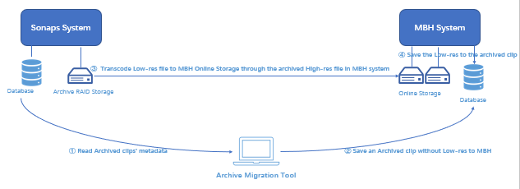

* **Description:**

1. 环境部署：

* 迁移工具能访问Sonaps系统的Archive Server
* 迁移工具能访问MBH系统的Hive Node
* MBH系统的MPC服务能访问Sonaps系统的HDD近线存储

1. 为避免迁移工具修改现场已有数据库：

* 迁移工具执行前，手动将Sonaps数据库媒资素材表单导出到迁移工具本地数据库中，迁移工具只会迁移手动导入到本地数据库中的媒资素材
* 在迁移工具执行期间或执行之后，若sonaps中产生了新的媒资素材，要确保这些新媒资素材成功迁移到Hive中，需要将这些新产生的媒资素材表单数据手动导出到迁移工具本地数据库表单中，启动迁移工具执行新媒资素材的迁移

1. 迁移原理：

* 迁移工具循环扫描Sonaps媒资素材，并按照GUI中的步骤①到步骤③完成一个媒资素材低质量及元数据的迁移。
* 迁移流程如下：

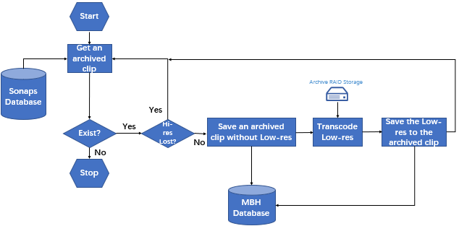

* 迁移工具既不会搬移素材的高质量也不会搬移素材的低质量物理文件，素材的高质量物理文件直接存放在“Archive RAID Storage”中，而素材的低质量是在MBH系统中由MPC直接访问“Archive RADI Storage”近线存储转码得到。
* 素材的关键帧文件和mark点图标文件是在MBH入库离线素材时由MBH系统产生。

1. 迁移完成后：

* 所有迁移到MBH系统中的Sonaps媒资素材均属于同一个创建者，此创建者是迁移工具中配置的Creator。
* MBH系统“Public Material”节点下产生一个“Archived”（可配置）文件夹，所有迁移完成的素材均按照Sonaps中Archive节点下的Folder结构存放在一级目录“Archived”下。

FID-002: 迁移工具

* **Operate Step**:

1. 配置Archive Migration Tool的Creator和Concurrency Number
2. 运行Archive Migration Tool
3. 点击Start按钮启动迁移，在Tasks页面中可查看正在迁移的任务
4. 点击Stop按钮停止迁移
5. 点击History页面可查看已结束迁移的任务，包括成功迁移和失败迁移
6. 点击对话框右上角Close按钮结束迁移，并关闭窗口

* **GUI:**

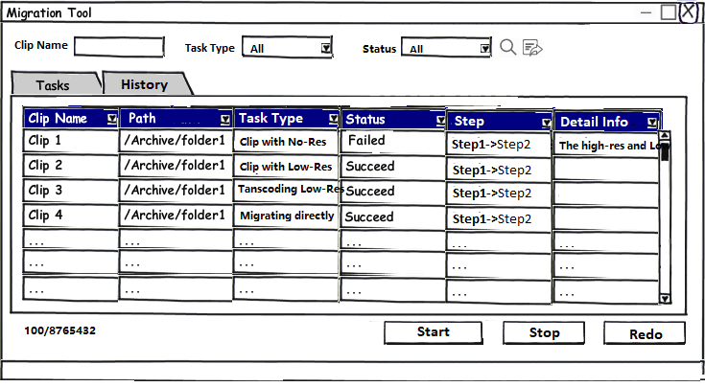

* **Description:**

1. 迁移工具支持：

* Start启动迁移任务
* Stop停止迁移任务
* Redo重做迁移失败的任务
* 展示正在迁移的任务
* 展示迁移结束的任务
* 通过Clip Name, Task Type, Status搜索任务
* 支持将当前选择Tab页的任务导出成xml或excel文件

1. Tasks和History任务列表

* Clip Name：媒资素材的素材名Clip Title
* Path：媒资素材所在Archive节点下的Folder路径
* Task Type：任务类型，包括

1. Clip with No-Res ---媒资素材高质量和低质量均不完整，这种素材无法成功迁移
2. Clip with Low-Res ---媒资素材高质量不完整，这种素材无法成功迁移
3. Transcoding Low-Res ---媒资素材低质量不完整，或者低质量不是MP4文件，迁移时会先入库MBH一个没有低质量的离线素材，然后发起流程根据媒资高质量转码产生此离线素材的低质量

* Status：任务状态，包括

1. Migrating ---正在迁移
2. Failed ---迁移失败
3. Succeed ---迁移成功

* Step：任务步骤，包括

1. Preparing -> Save Clip -> Transcoding Proxy

* Detail Info: 失败任务详细信息，当任务Status为Failed失败时，此列才有显示值
* 列排序：所有列均支持按照ASCII码手动升序或降序排列，默认情况 下按照Clip Name升序排序
* 多选或全选：

1. 支持Ctrl+A全选List中显示的所有任务
2. 支持Ctrl多选List中某些任务
3. 支持Shift批量选择List中的某些任务
4. 任务搜索

* 选择某一个Tab页（Tasks页或History页）
* 输入Task Name，或者选择Task Type/Status，点击按钮则在当前Tab页中显示出符合条件的任务
* 切换Tab页，若搜索项中包含条件，则只显示符合搜索条件的任务

1. 任务导出

* 选择某一个Tab页
* 点击导出按钮，选择导出路径，以xml或excel方式导出当前Tab页显示的所有任务

1. Start和Stop

* Start：开始整个系统的迁移
* Stop：停止迁移，点击此按钮后Tasks里面正在Migrating的任务会继续完成，但不会再开始新的迁移任务
* Redo：当在History中选中的任务含有Failed状态时，此按钮可用，点击后，重做选中的Failed任务

1. 当前显示任务数及迁移任务总数 （如100/86023）

* 在List的左下方用 “当前任务数/迁移任务总数” 的方式显示
* 当前任务数：当前选中的Tab页（Tasks或History页）中显示的任务个数
* 迁移任务总数：Sonaps系统中需要迁移的媒资素材总数

FID-003: 元数据映射关系

|  |  |
| --- | --- |
| **Sonaps元数据** | **MBH元数据** |
| Material -> Title | Basic Info -> Title |
| Material -> Rights | Basic Info -> Rights |
| Material -> Comments | Basic Info -> Comments |
| Material -> Address | Basic Info -> Address (按照Sonaps的Address结构统一放在一级目录“Archived”下) |
| Material -> Item Name | Basic Info -> Item Name |
| Material -> Journalist | Basic Info -> Journalist |
| Material -> Category | Basic Info -> Category |
| Material -> Program Name | Basic Info -> Program Name |
| Material -> Attribute (16:9SD) | Basic Info -> Attribute (16:9SD) |
| Planning -> Place | Planning -> Place |
| Planning -> Planning Date/Time | Planning -> Planning Date |
| Planning -> Director | Planning -> Director |
| Planning -> Input by | Planning -> Input by |
| Planning -> Photographer | Planning Photographer |
| Planning -> Reporter | Planning -> Reporter |
| Planning -> Other Engineer | Planning -> Other Engineer |
| Planning -> Equipment | Planning -> Equipment |
| Planning -> Contact Info. | Planning -> Contact Info. |
| Filling -> Input source | Filling -> Input Source |
| Filling -> Video Format | Filling -> Video Format |
| Filling -> Audio Format | Filling -> Audio Format |
| Filling -> Ingest Channel name | Filling -> Ingest Channel name |
| Filling -> Ingest device ID | Filling -> Ingest Device ID |
| Filling -> Quantity of audio channels | Filling -> Quantity of audio channels |
| Filling -> SOF(STC) | Filling -> SOF(STC) |
| Filling -> EOF | Filling -> EOF |
| Filling -> Total Duration | Filling -> Total Duration |
| Filling -> SOM | Filling -> SOM |
| Filling -> EOM | Filling -> EOM |
| Filling -> Material Duration | Filling -> Material Duration |
| Filling -> Stream channel | Filling -> Stream Channel |
| Filling -> Source Tape Barcode | Filling -> Source Tape Barcode |
| Filling -> Source Tape Title | Filling -> Source Tape Title |
| Filling -> Backup Tape Title | Filling -> Backup Tape Title |
| Essence Mark -> Essence Marker | Mark -> Essence Mark |
| Essence Mark -> Scene Marker | Mark -> Scene Mark |
| Essence Mark -> Change Marker | Mark -> Change Mark |
| Essence Mark -> Logging Marker | Mark -> Logging Mark |
| History -> Modified (Date)(Time) | History -> Modified (Date) (Time) |
| History -> Modified on | History -> Modified on |
| History -> Create Date | History -> Create Date |
| History -> Filling Start | History -> Filing Start (Date) (Time) |
| History -> Filling End | History -> Filling End (Date) (Time) |
| History -> Field by | History -> Filed by |
| History -> Field from | History -> Filed from |
| History -> Edited by | History -> Edited by |
| History -> Edited on | History -> Edited on |
| History -> Seq.Name | History -> Sequence Name |
| Original Metadata -> User Media ID | Original Metadata -> User Media ID |
| Original Metadata -> Main Title | Original Metadata -> Main Title |
| Original Metadata -> Comments | Original Metadata -> Comments |
| Original Metadata -> Clip Title | Original Metadata -> Clip Title |
| Original Metadata -> Created by | Original Metadata -> Created by |
| Original Metadata -> Created | Original Metadata -> Created |
| Original Metadata -> Duration | Original Metadata -> Duration |
| Original Metadata -> STC | Original Metadata -> STC |
| Original Metadata -> Video Format | Original Metadata -> Video Format |
| Original Metadata -> Audio Format | Original Metadata -> Audio Format |
| Original Metadata -> Comments | Original Metadata -> Comments |
| Original UMID -> Basic UMID | Original UMID -> Basic UMID |
| Original UMID -> Status | Original UMID -> Status |
| Original UMID -> Attribute | Original UMID -> Attribute |
| Original UMID -> Item | Original UMID -> Item |
| Original UMID -> Value | Original UMID -> Value |
| File List -> Filename | File List -> File Name (路径需要映射转换为Hive路径) |
| File List -> Quality | File List -> Quality |
| File List -> Track | File List -> Track |
| File List -> Passage | File List -> Passage |
| File List -> In | File List -> In |
| File List -> Out | File List -> Out |
| File List -> SOF | File List -> SOF |
| File List -> EOF | File List -> EOF |

# **Performance Specification**

Subsystem/Function: Title

* **Description**

Show the detail info of performance, include pre-condition, indicator of performance, 3rd party device and etc.

* **Target**

Performance target include bottom-line

# **Supplementary**

Glossary

|  |  |
| --- | --- |
| **Term** | **Description** |
| CT | Clip Trimmer |
| TC | Timecode |
|  |  |

Reference Document

|  |  |
| --- | --- |
| **Index** | **Document** |
| 1 | xxxxx.docx |
|  |  |